LOOK!! HURRY IN!
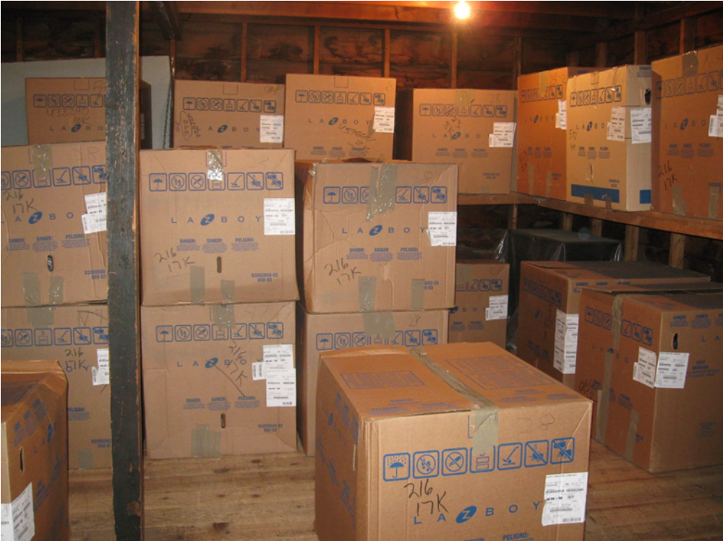

Prices on foam and wood products have gone up. That means… furniture prices are going up. We bought a lot of La-Z-Boy recliners before the factory price increase. That means… you can still get great La-Z-Boy recliners at yesterdays price while this inventory is available.

